# Creating and Filtering a TTK

1. Export the information needed from Alchemy catalyst as a Tab-delimited text file. This can be an entire software TTK, or only certain resources. Save file with the following standard: ProductGlossary_LANGUAGE. Eg:

* CamioGlossary_FRA
* CMMManagerGlossary_ITA
* FocusGlossary_PLK
* InspectXGlossary_RUS

1. Open \\pc-uk-de-tdoc2\E\LOCALISATION\Software Glossaries and open “Glossary Consistency Check.xlsm”.
2. Copy your text file into the same folder as the excel spreadsheet.
3. In the excel spreadsheet, open the correct worksheet and click the “Create Glossary” button for the correct language and product.

Excel will now automatically filter out any identical translations, sort all entries alphabetically and highlight all inconsistencies. Once filtered it will save to a new file appended with “_ConsistencyChecked”.

1. All inconsistent strings will appear at the top of the sheet in red. This will only sort identical strings. To find a string used within other strings, use the filters.

# Using the Filters

In this example, we will be using the French Camio translation to look for all instances of “Feature” and its translation.

1. Click on the drop-down arrow in cell A1. This will hang for a few seconds.

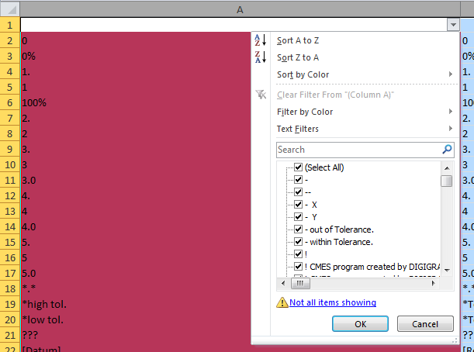

1. Select “Text Filters” then “Containing Text”. Type the word you’re searching for into the text-box next to “Contains”. For this example type “Feature” and click OK.

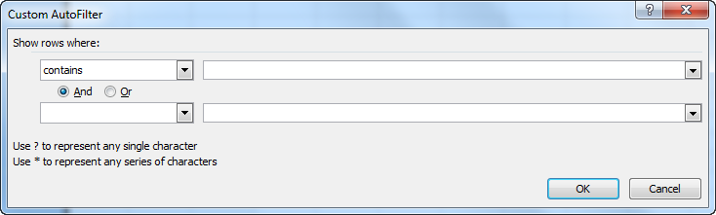

1. Both columns will be filtered so that only cells containing “Feature” in the English column will appear. From here we can see that the most common translation of Feature is “entité”.
2. Open the filter drop-down arrow in cell B1. Select “Text Filters” and “Does not Contain”. This will allow you to filter any translations which do NOT contain a certain word. Enter the word “entité” and click OK.
3. The rows will now be filtered to show all strings with “Feature” in English and do not contain “entité”. This can be used to quickly find inconsistent translations once the correct translation has been found.

# Finding Untranslated strings

Occaisionally, an English to English string will become leveraged in as translated, leaving English strings marked as translations. To find these, click the “Filter Untranslated” button which appears on the new sheet. This will bring all untranslated segments to the top of the sheet. Check these to find any strings which should be translated.

# Repairing Translation Memory

1. Adjustments can be made to the translation memory inside Excel.
2. Once finished, save the file and close Excel. A tab-delimited file with the extension “_ConsistencyChecked” will be saved in the same folder as the spreadsheet. When prompted, accept saving the file as .txt. This will remove
3. This text file can be used as a translation memory. Revert the TTK which you started with and leverage against the text file you created. This will copy all improvements back into the TTK.